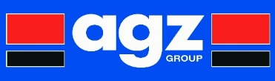

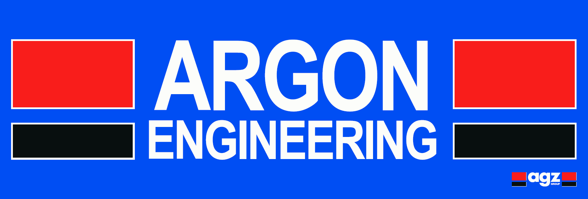  

**Health & Safety Policy Statement**

The following is a statement of the Companies General Health & Safety Policy in accordance with section 2 of the Health and Safety at Work etc. Act 1974.

It is the policy of AGZ Group to ensure so far as is reasonably practicable the Health, Safety and Welfare of all of the operatives working for the Company’s or other persons who may be affected by our undertakings.

AGZ Group acknowledges that the key to successful Health & Safety management requires an effective policy, organisation and arrangements, which reflect the commitment of senior management. To sustain that commitment we will continually measure, monitor and revise where necessary an annual plan to ensure that Health and Safety standards are adequate.

The Managing Director will implement the Companies Health and Safety Policy and recommend any changes to meet new circumstances. AGZ Group recognises that successful Health and Safety Management contributes to successful business performance and will allocate adequate finances and resources to meet these needs. AGZ Group will comply with our customer, regulatory, legislative and contractual obligations.

The management of Argon, Gillrick & Zeus look upon the promotion of Health and Safety measures as a mutual objective for themselves and their operatives at all levels. It is therefore, the policy of the management to do all that is reasonably practicable to prevent personal injury and damage to property. The Companies also aim to protect everyone, including the public, insofar as they come into contact with the Company or its activities, from any foreseeable hazard and danger.

All operatives have duties under the Health & Safety at Work etc. Act 1974 and they are informed of their personal responsibilities to take due care for the Health & Safety of themselves and to ensure that they do not endanger other persons by their acts or omissions. They are also informed that they must co-operate with the Company in order that it can comply with the legal requirements placed upon it and in the implementation of this Policy.

Our Companies will ensure continued consultation with the workforce to enable all viewpoints and recommendations to be discussed at regular intervals.

Our Companies will ensure a systematic approach to identifying hazards, assessing the risk determining suitable and sufficient control measures and informing operatives.

Our Companies will provide, so far as is reasonably practicable, safe places and systems of work, safe plant and machinery, safe handling of materials and substances, the provision of adequate safety equipment and ensure that appropriate information, instruction, training and supervision is given.

Our Companies regards all Health and Safety Legislation as the minimum standard and expects management to achieve their managerial targets without compromising Health and Safety.

**This document was last reviewed on Date: 07.07.2021**

**Next Review Date: 05.01.2022**

**A signed copy of this statement is available on request.**