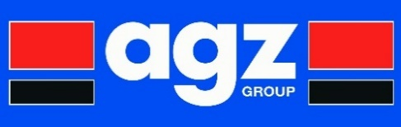

**Modern Slavery Act Policy**

The Modern Slavery Act 2015 aims to protect individuals held in conditions of slavery or servitude or required to perform forced or compulsory labour. This can include work or services provided in circumstances which constitute exploitation, both in the UK and abroad.

**The AGZ Group comply with the Act in terms of:**

* The organisation’s structure, its business and its supply chains;
* It’s policies in relation to slavery and human trafficking;
* It’s due diligence processes in relation to slavery and human trafficking in it’s business supply chains;
* The parts of its business and supply chains where there is a risk of slavery and human trafficking taking place, and the steps it has taken to assess and manage that risk;
* It’s effectiveness in ensuring that slavery and human trafficking is not taking place in its business or supply chains, measured against such performance indicators as it considers appropriate;
* The training about slavery and human trafficking available to its staff.

**Further details about the statement are available from Management.**

**This document was last reviewed April 2018.**

**A signed copy of this statement is available on request.**